**Conceptual Diagram**

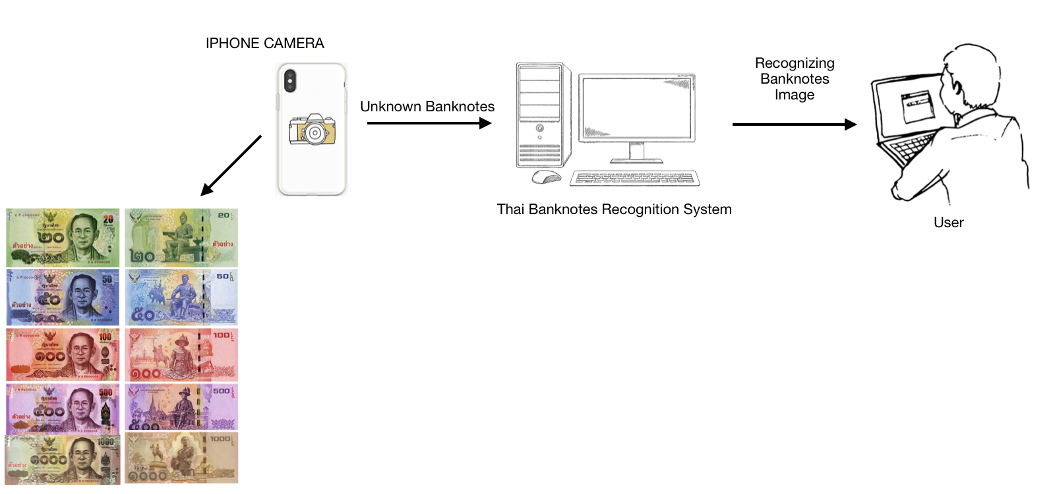

*Figure 1: Conceptual Diagram*

**Structure Chart**

The Thai banknote recognition system consists of five main process modules as shown in figure 2:

1) image acquisition

2) image preprocessing

3) feature extraction

4) image recognition

5) result presentation

**Image acquisition**

The whole data which are images should be taken from bird-eye-views as input in this system. The banknotes have to set the same environment. While taking a picture, the mobile has to available a flashlight mode. All of the banknotes, which are a dataset, have to place in a horizontal line.

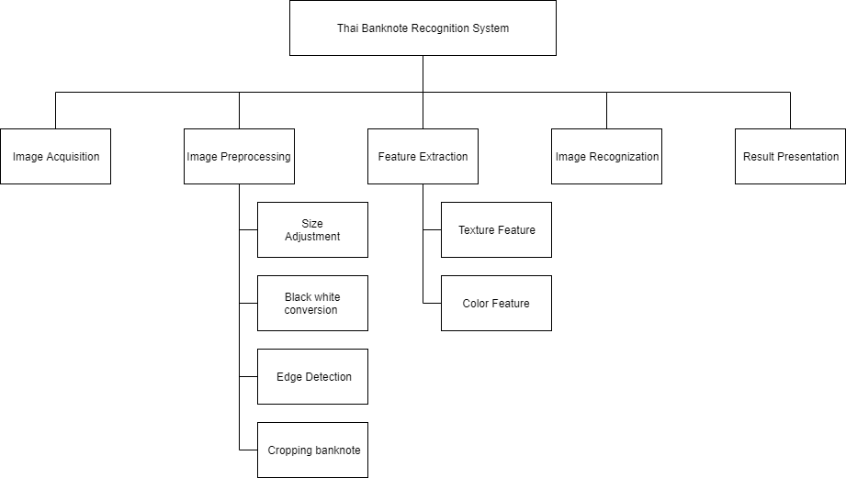

Figure 2: Structure Chart

**Image preprocessing**

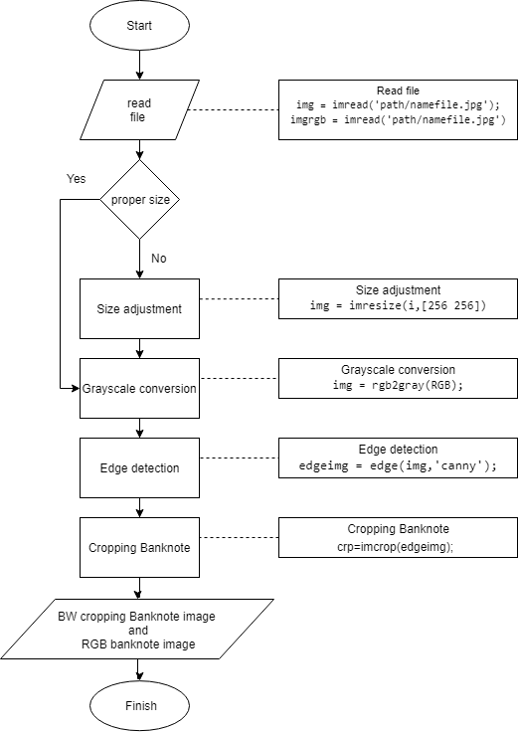

*Figure 3: Image Preprocessing Chart*

1. Size adjustment

After reading two files, if the picture is an incorrect size in case of images come from different devices, the picture will step in size adjustment process. This process will resize two photos to be the same size.

1. Grayscale conversion

Make one photo to be grayscale for using in texture feature. For the RGB picture, there's no need to step in this process because it will use in the color feature process.

1. Edge detection [by using candy filter]

After grayscale conversion, the next process is edge detection by using a candy filter because it is suitable for Sobel detection.

1. Cropping Banknote

The unwanted part of the image will be removed by this process. It will be left only the bank. Then the picture is ready to use in the image recognition process.

**Feature extraction**

There are two features that were used in the Thai Banknote Recognition System.

1. Texture feature
2. Color feature: The system will keep the mean color of each color into the excel file

**Image Recognition**

After preparing an excel file, there will be an image recognition method. The technique which this system used to compare two images is Euclidean distance. This is owing to a Euclidean distance formula can be used to calculate the distance between two data points in a plane. If the value is very few, it meant that two datasets are very similar as well. The equation is below in figure 4.

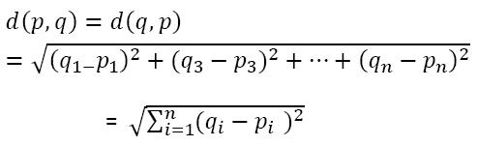

*Figure 4:*  Euclidean distance equation

**Result Presentation**

There will be 2 axes charts which are upload pictures and result in pictures. The edit bar which below those charts represents the name of the file. There are also 3 buttons which are the upload button, the train button, and the recognition button (test). As shown in figure 5.

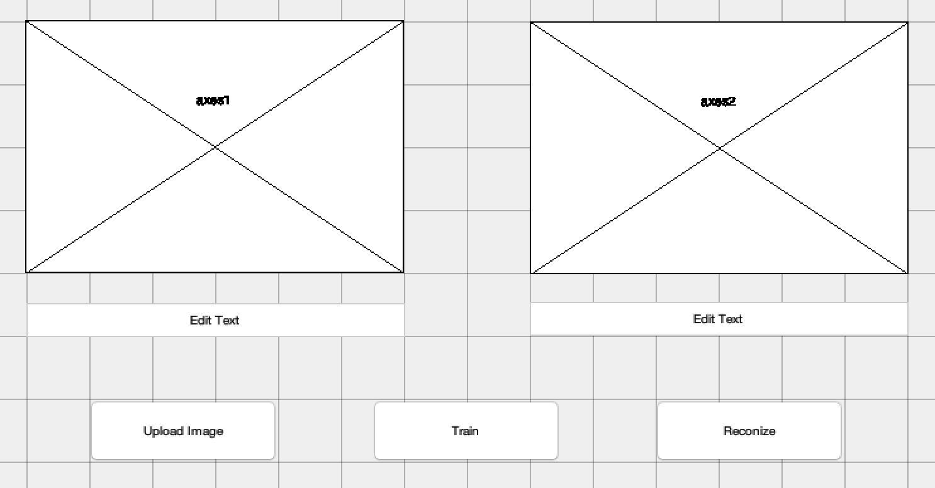

*Figure 5: MATLAB interface of this system*